# Project Report

## INTRODUCTION:

* 1. **Project Overview:**

The Citizen AI Engagement Platform is a cutting-edge solution designed to foster meaningful interactions between citizens and government institutions. By harnessing the power of AI, this platform enables personalized communication, streamlines feedback mechanisms, and promotes inclusive decision-making processes.

* 1. **Purpose:**

The purpose of this platform is to:

1. Enhance Citizen Participation: Encourage active engagement and participation from citizens in governance processes.
2. Improve Transparency: Provide clear and accessible information, ensuring citizens are informed and empowered.
3. Foster Trust: Build trust between citizens and government institutions through responsive and effective communication.
4. Drive Inclusive Decision-Making: Ensure that diverse perspectives and needs are considered in policy-making processes.

## IDEATION PHASE:

### Problem Statement:

**Define the Problem Statements**

|  |  |
| --- | --- |
| Date | 27 June 2025 |
| Team ID | LTVIP2025TMID59932  LTVIP2025TMID59941 |
| Project Name | Citizen AI - Intelligent Citizen Engagement Platform |
| Maximum Marks |  |

Customer Problem Statement Template:

Create a problem statement to understand your citizen's point of view. The Citizen Problem Statement Template helps civic teams and government bodies focus on what truly matters to create public services and digital experiences that people trust and engage with.

A well-defined citizen problem statement enables your team to identify the right solutions for the real challenges that citizens face. Through this approach, you build empathy with citizens and gain a deeper understanding of how they interact with and perceive public services enabled by the Citizen AI Platform.

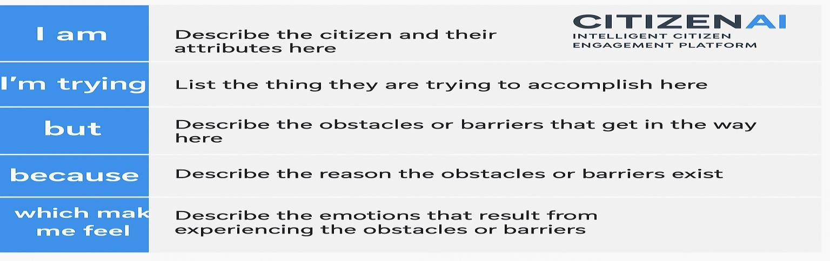

**Example:**

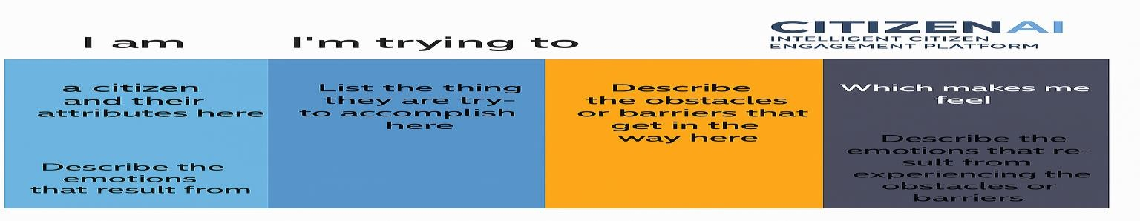

### Empathy Map Canvas:

**Ideation Phase Empathize & Discover**

|  |  |
| --- | --- |
| Date | 27 June 2025 |
| Team ID | LTVIP2025TMID59932  LTVIP2025TMID59941 |
| Project Name | Citizen AI - intelligent citizen engagement platform |
| Maximum Marks |  |

Empathy Map Canvas:

An Empathy Map is a clear, concise visual tool designed to capture insights about citizens’ behaviors, feelings, and needs. In the context of Citizen AI, it enables public service teams and

AI developers to deeply understand the people they serve—their lived experiences, goals, and frustrations.

Creating truly impactful AI-driven civic solutions requires deep empathy with citizens. The Empathy Map helps teams step into the shoes of the citizen to uncover the real, often unmet, needs behind their interactions with public systems.

Example:

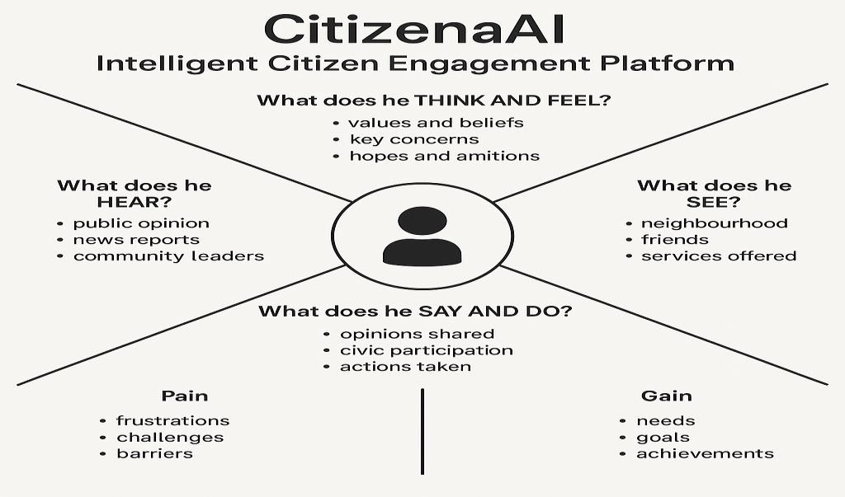

**Example: citizen Engagement :**

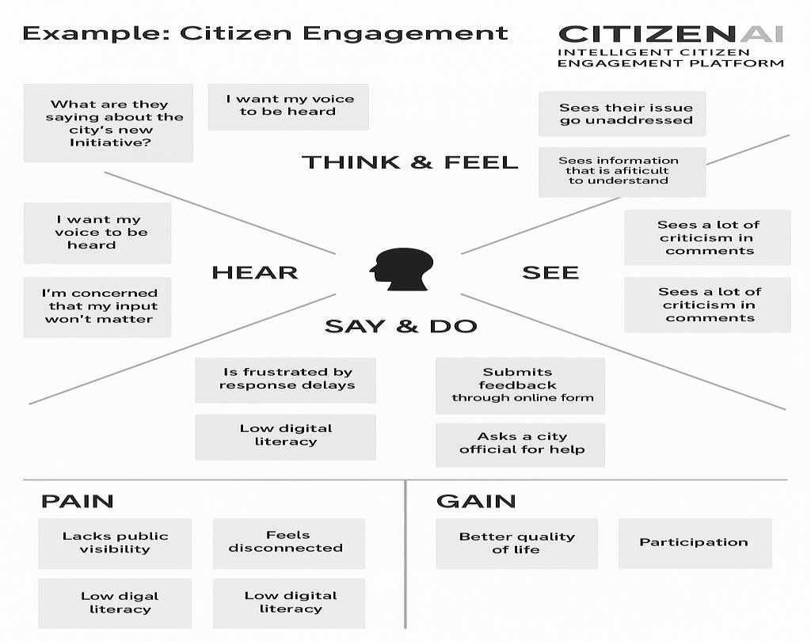

* 1. **Brainstorming:**

**Ideation Phase**

**Brainstorm & Idea Prioritization Template:**

|  |  |
| --- | --- |
| Date | 27 June 2025 |
| Team ID | LTVIP2025TMID59932  LTVIP2025TMID59941 |
| Project Name | Citizen AI - Intelligent Citizen Engagement Platform |
| Maximum Marks |  |

Brainstorm & Idea Prioritization Template:

Citizen AI Intelligent Citizen Engagement Platform: Idea Generation & Prioritization Just as traditional brainstorming fosters an open environment for creative problem-solving, a Citizen AI Intelligent Citizen Engagement Platform provides a dynamic space where every citizen can actively participate in shaping their community. This platform encourages the free flow of ideas, prioritizing the volume of diverse input over initial perceived value. Out-of-the-box suggestions are welcomed and, through the power of AI, can be built upon and refined. The platform facilitates collaboration, allowing citizens and AI to work together to develop a rich array of creative solutions for civic challenges.

Step-1: Team Gathering, Collaboration and Select the Problem Statement:

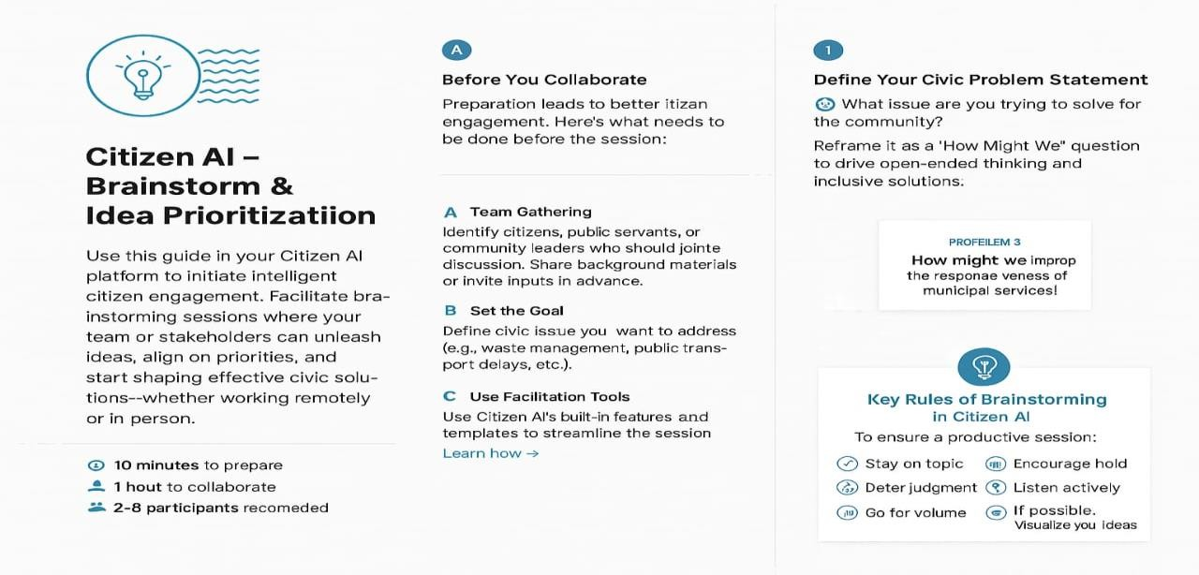

Step-2: Brainstorm, Idea Listing and Grouping:

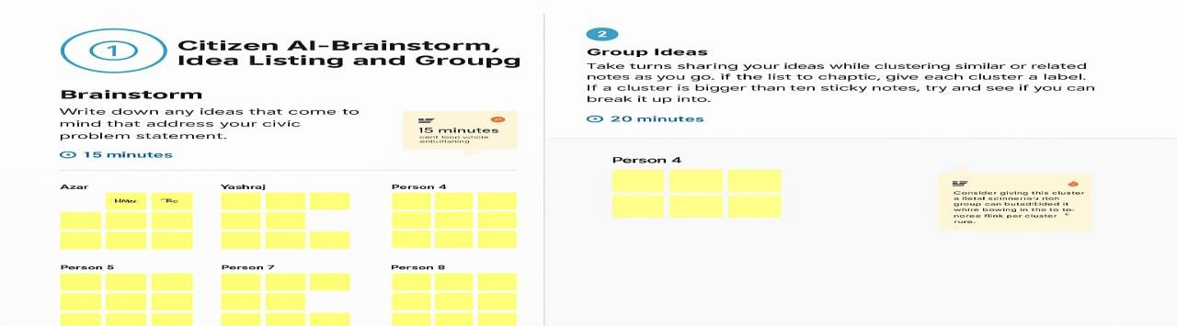

Step-3:Idea-Prioritization:

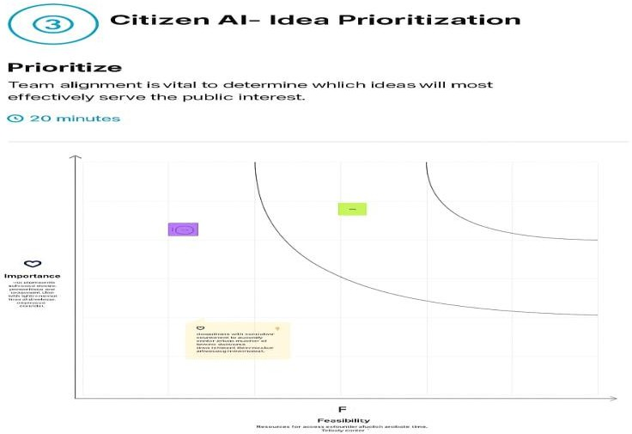

## REQUIREMENT ANALYSIS:

* 1. **Customer Journey Map:**

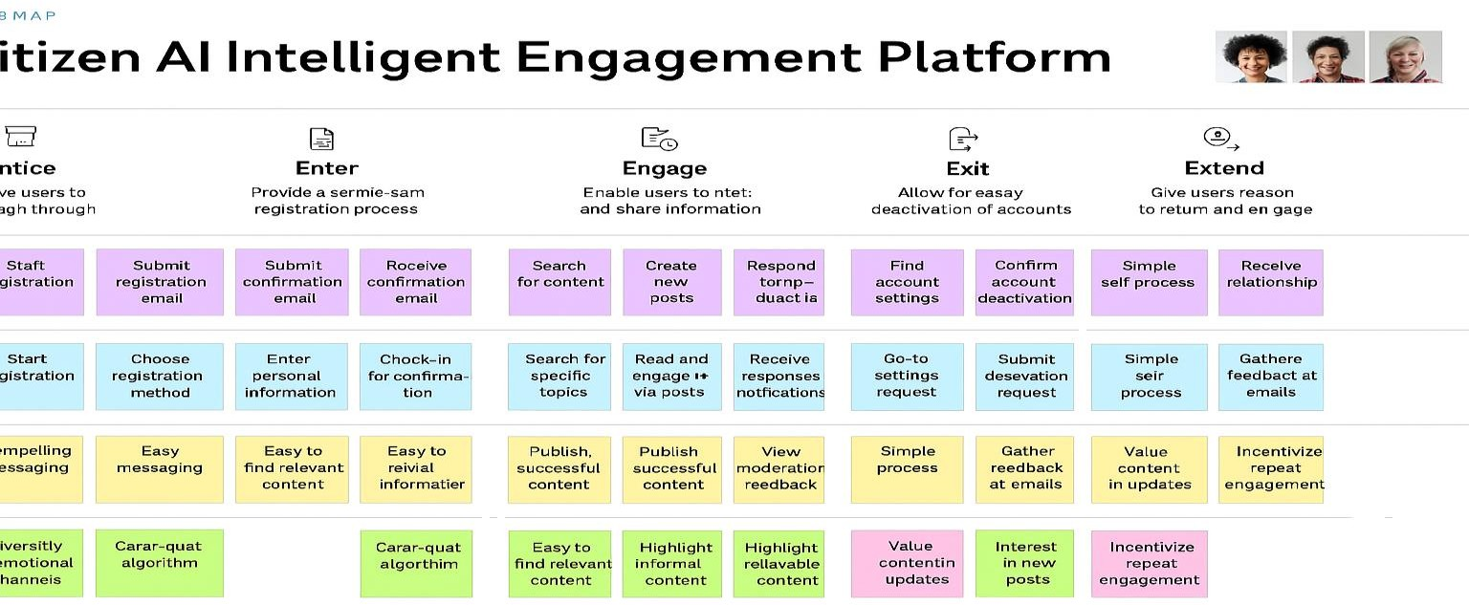

* 1. **Solution Requirement:**

**Project Design Phase-II**

**Solution Requirements (Functional & Non-functional)**

|  |  |
| --- | --- |
| Date | 27 June 2025 |
| Team ID | LTVIP2025TMID59932  LTVIP2025TMID59941 |
| Project Name | Citizen AI - Intelligent Citizen Engagement Platform |
| Maximum Marks |  |

**Functional Requirements:**

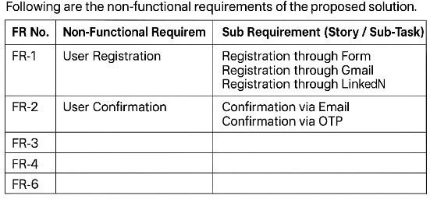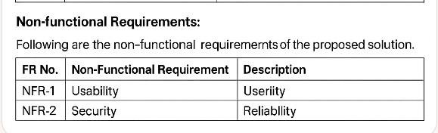

* 1. **Data Flow Diagram:**

**Project Design Phase-II**

**Data Flow Diagram & User Stories**

|  |  |
| --- | --- |
| Date | 27 June 2025 |
| Team ID | LTVIP2025TMID59932  LTVIP2025TMID59941 |
| Project Name | Citizen AI - Intelligent Citizen Engagement Platform |
| Maximum Marks |  |

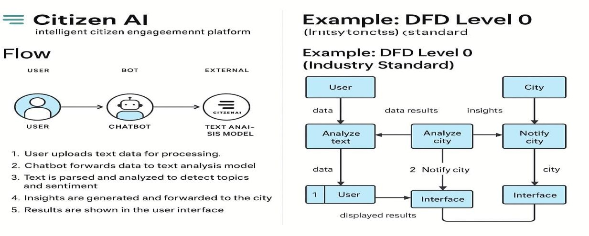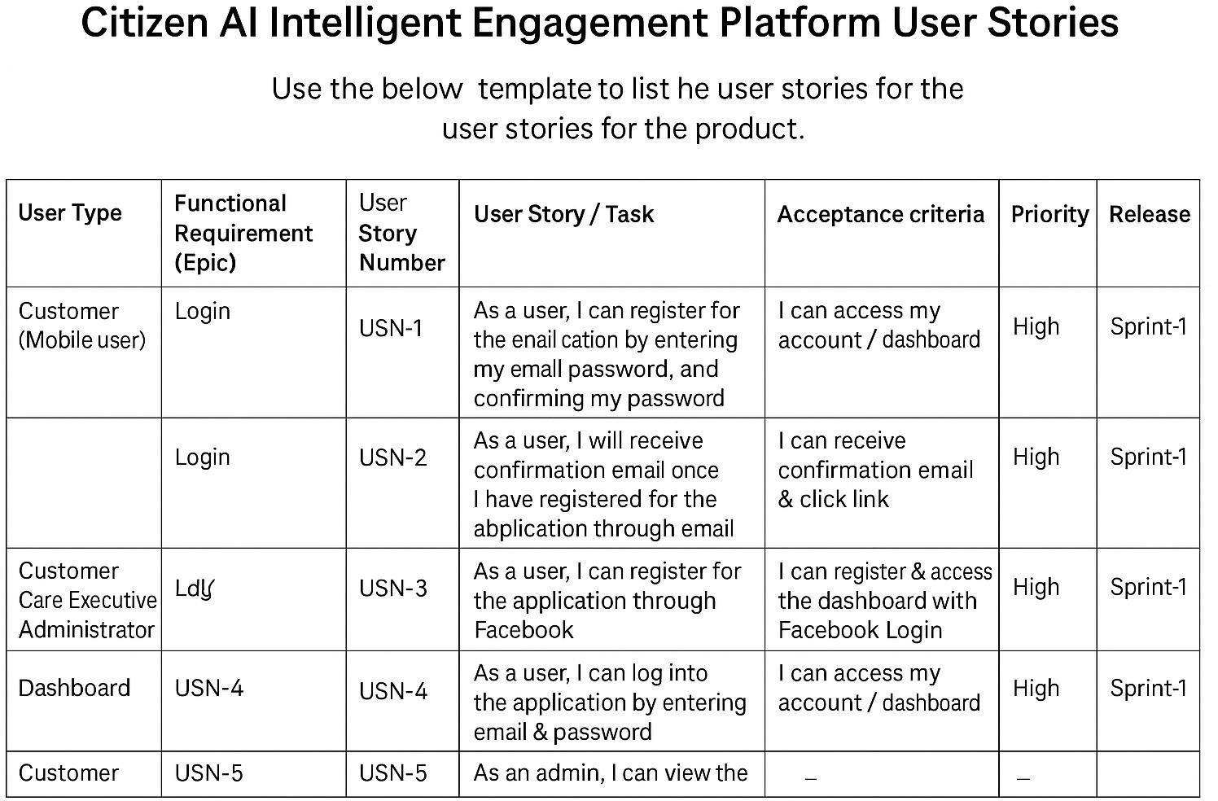

* 1. **Technology Stack:**

**Project Design Phase-II Technology Stack (Architecture & Stack)**

|  |  |
| --- | --- |
| Date | 27 June 2025 |
| Team ID | LTVIP2025TMID59932  LTVIP2025TMID59941 |
| Project Name | Citizen AI - Intelligent Citizen Engagement Platform |
| Maximum Marks |  |

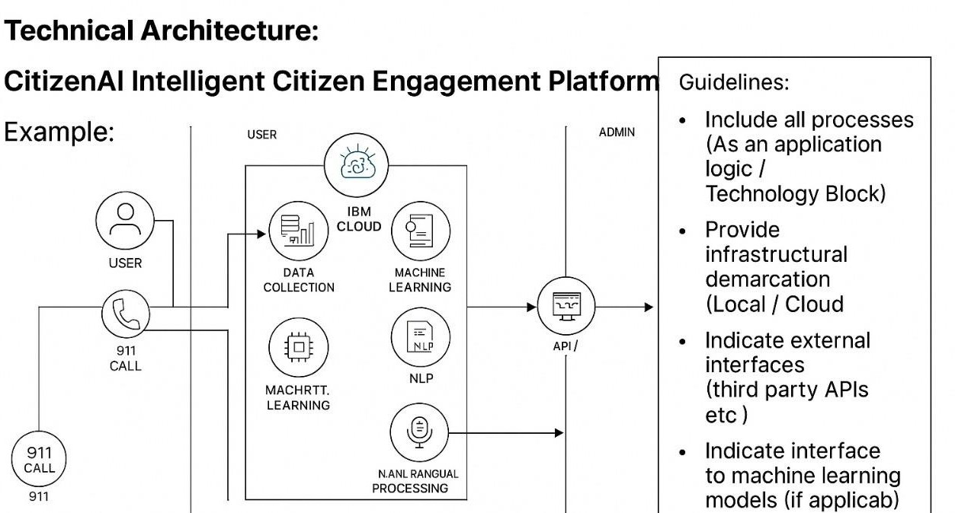

**Table 1:**

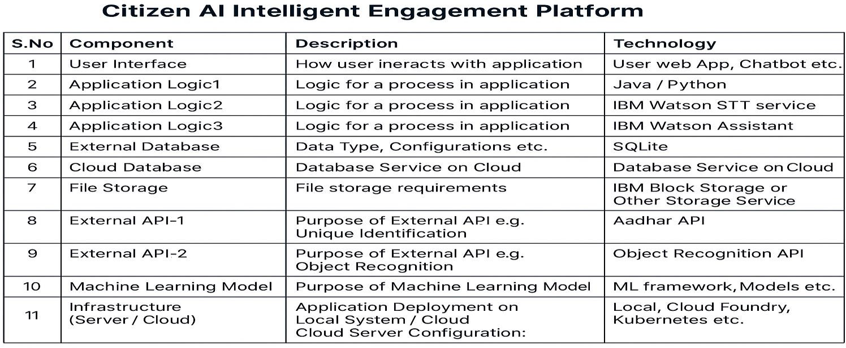

## PROJECT DESIGN:

* 1. **Problem Solution Fit:**

**Project Design Phase Problem – Solution Fit Template**

|  |  |
| --- | --- |
| **Date** | **27 June 2025** |
| **Team ID** | **LTVIP2025TMID59932**  LTVIP2025TMID59941 |
| **Project Name** | **Citizen AI-Intelligent Citizen Engagement Platform** |
| **Maximum Marks** |  |

Problem-Solution Fit Template:

The Problem-Solution Fit is a powerful tool that ensures you've identified a genuine pain point for your customers and crafted a solution that truly addresses their needs. This template empowers entrepreneurs, innovators, and marketers to:

* + - Solve with Empathy: Tackle complex problems in a way that resonates with your customers' behaviors and preferences.
    - Accelerate Success: Leverage existing habits and channels to boost solution adoption and achieve faster results.
    - Communicate Effectively: Craft compelling messaging and triggers that speak directly to your target audience.
    - Build Trust: Identify the right problem-behavior fit and deliver solutions that alleviate frustrations, urgent needs, or costly issues.
    - Understand and Improve: Gain a deep understanding of your target group's situation and create meaningful improvements that make a lasting impact

Templet:

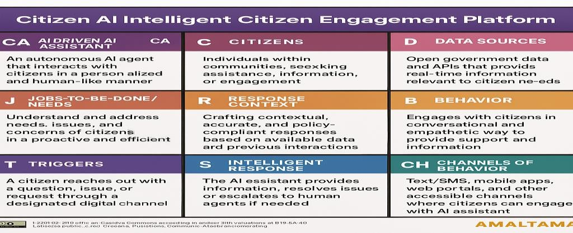

### Proposed Solution:

**Project Design Phase Proposed Solution Template**

|  |  |
| --- | --- |
| Date | 27 June 2025 |
| Team ID | LTVIP2025TMID59932 |
| Project Name | Citizen AI - Intelligent Citizen Engagement Platform |
| Maximum Marks |  |

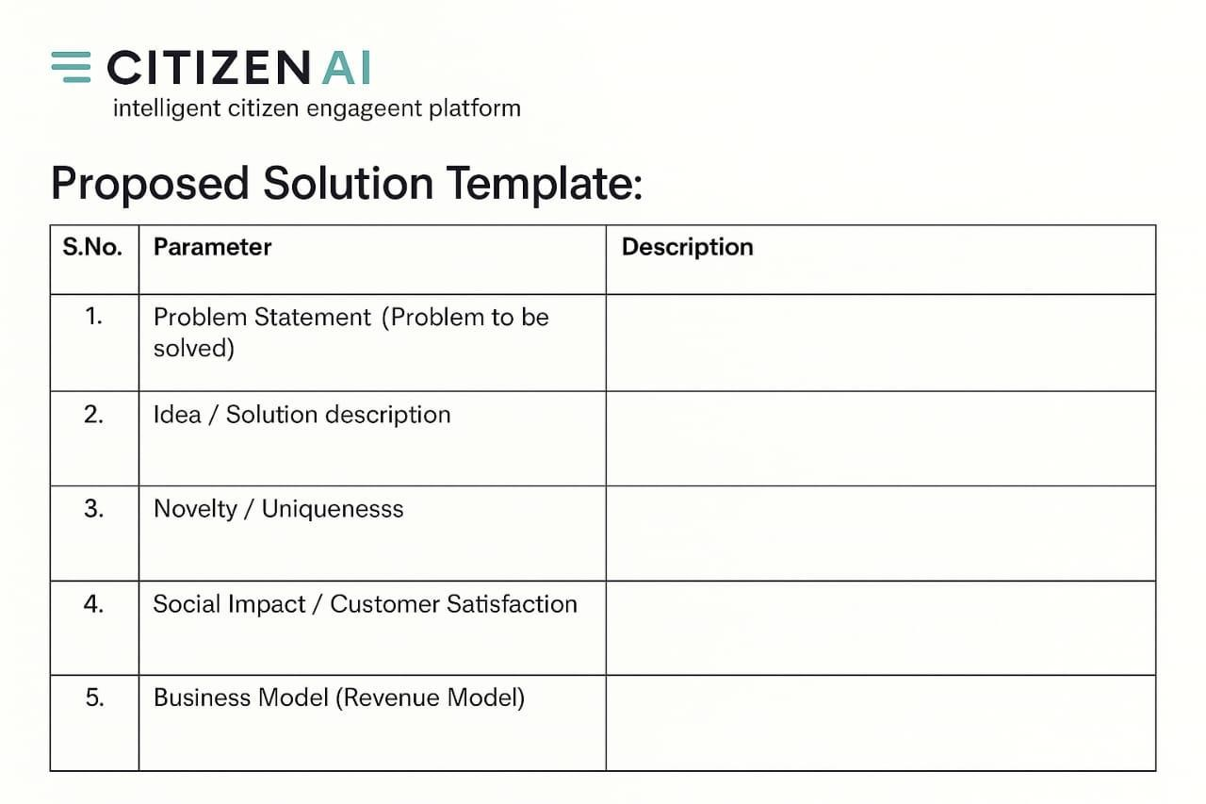Proposed Solution Template:Project team shall fill the following information in the proposed solution template**.**

### Solution Architecture:

**Proposed Solution Template:**

**Project Design Phase Solution Architecture**

|  |  |
| --- | --- |
| Date | 27 June 2025 |
| Team ID | LTVIP2025TMID59932  LTVIP2025TMID59941 |
| Project Name | Citizen AI - Intelligent Citizen Engagement Platform |
| Maximum Marks |  |

**Solution Architecture:**

Solution architecture for Citizen AI – Intelligent Citizen Engagement Platform is a structured and strategic process that connects civic challenges with innovative AI-driven technological solutions. It acts as a bridge between citizen needs and smart governance systems, ensuring effective public engagement and service delivery.

* + - Identify the Optimal AI-driven Solution
    - Design a Transparent and Scalable System
    - Detail Functionalities and Development Roadmap
    - Establish Technical and Operational Standards

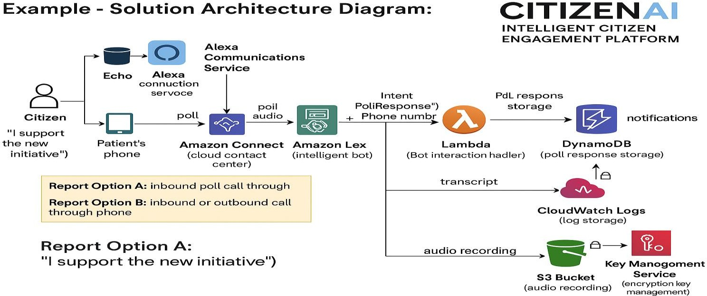

# PROJECT PLANNING & SCHEDULING:

### Project Planning:

**Project Planning Phase**

**Project Planning Template (Product Backlog, Sprint Planning, Stories, Story points)**

|  |  |
| --- | --- |
| Date | 27 June 2025 |
| Team ID | LTVIP2025TMID59932  LTVIP2025TMID59941 |
| Project Name | Citizen Ai - intelligent citizen engagement platform |
| Maximum Marks |  |

Product Backlog, Sprint Schedule, and Estimation (4 Marks)

Use the below template to create product backlog and sprint schedule

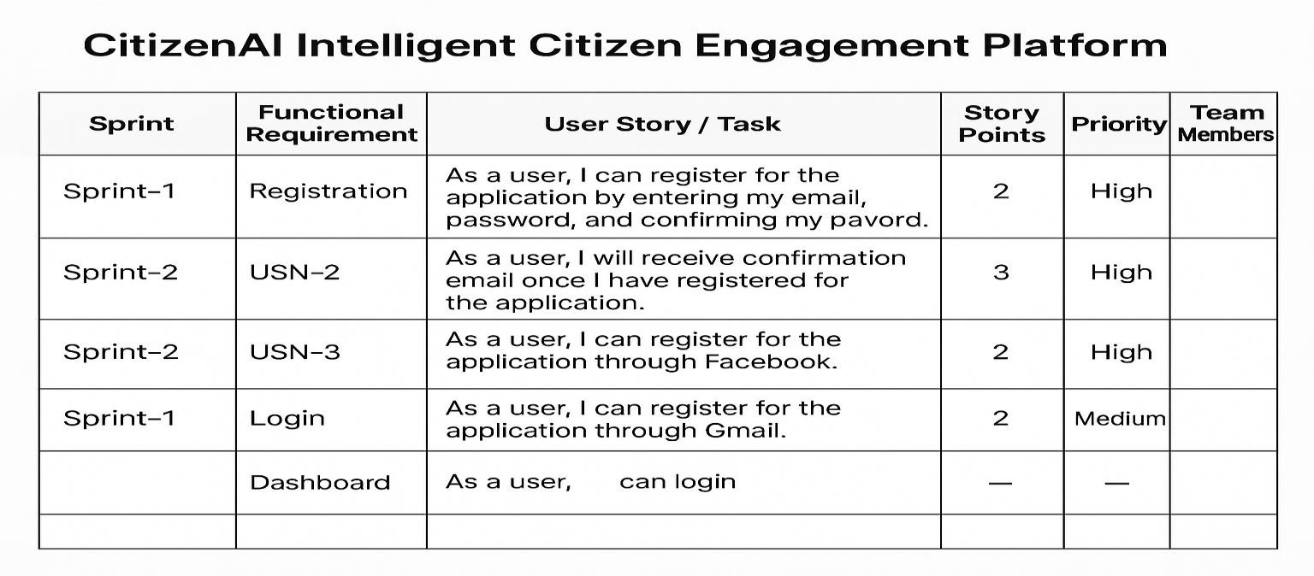

# FUNCTIONAL AND PERFORMANCE TESTING:

### Performance Testing:

Functional & Performance Testing Templat

|  |  |
| --- | --- |
| Date | 27 june 2025 |
| Team ID | LTVIP2025TMID59932  LTVIP2025TMID59941 |
| Project Name | Citizen AI - Intelligent Citizen Engagement Platform |
| Maximum Marks |  |

**Test Scenarios & Results:**

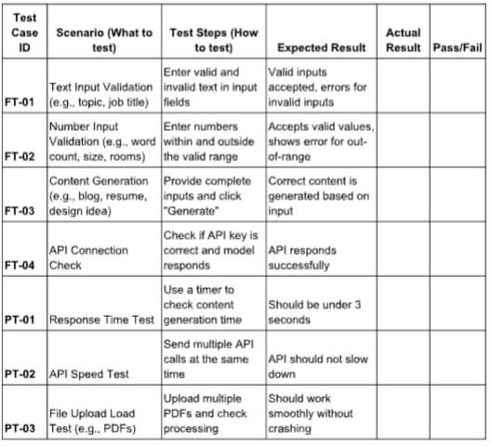

# RESULTS:

* 1. **Output Screenshots:**

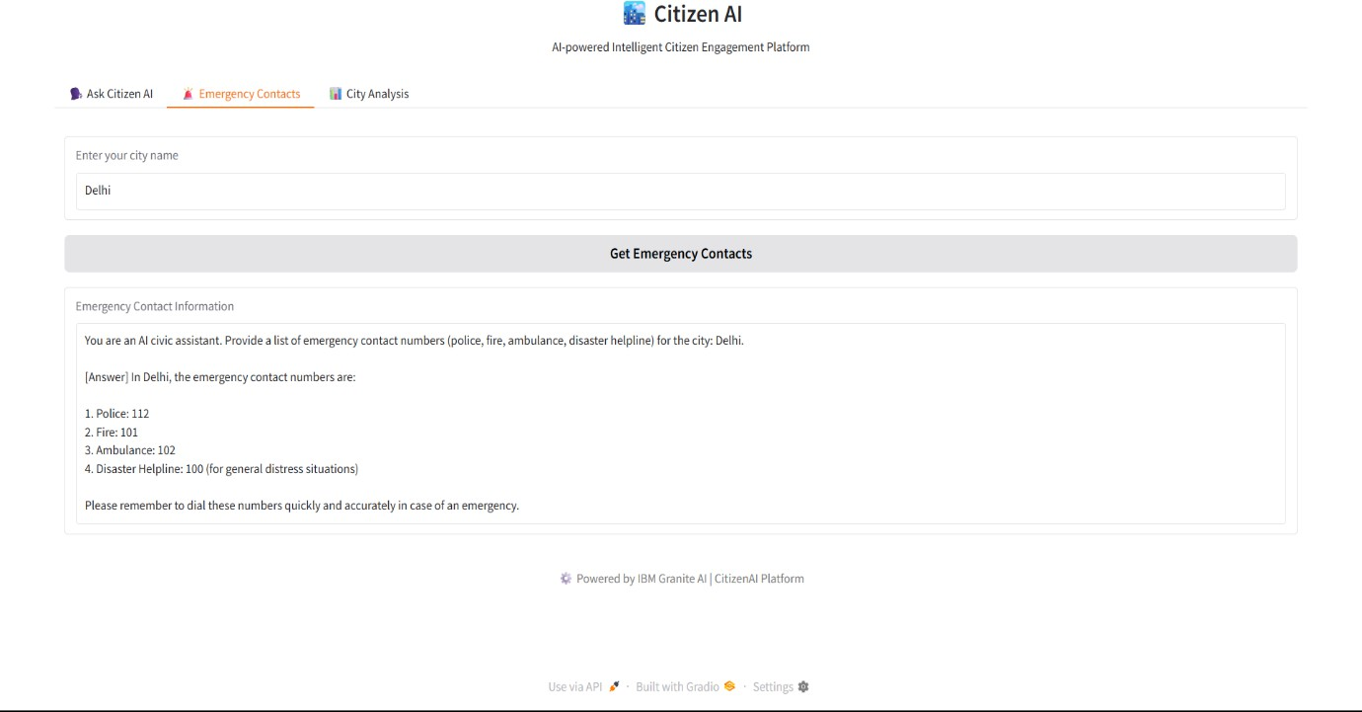

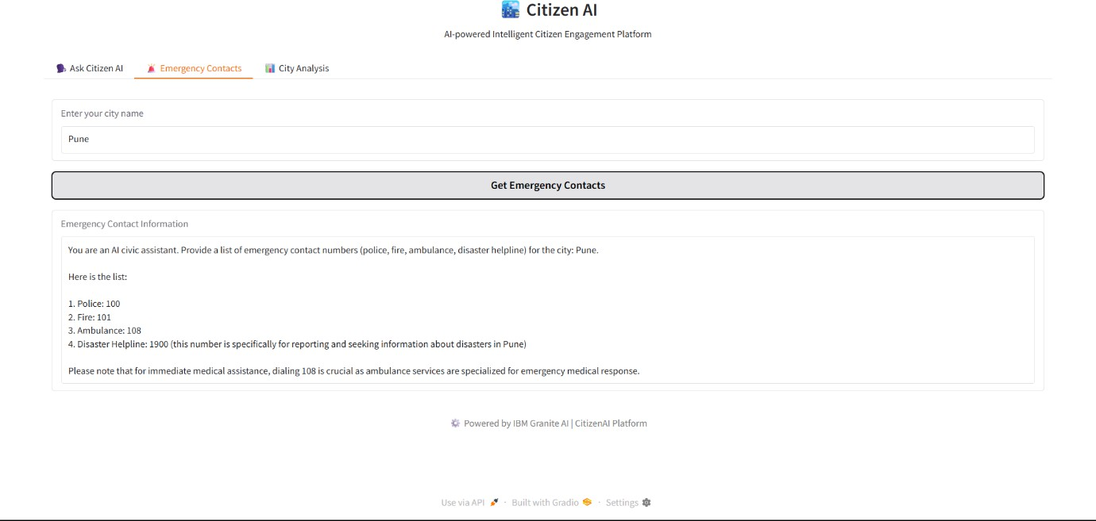

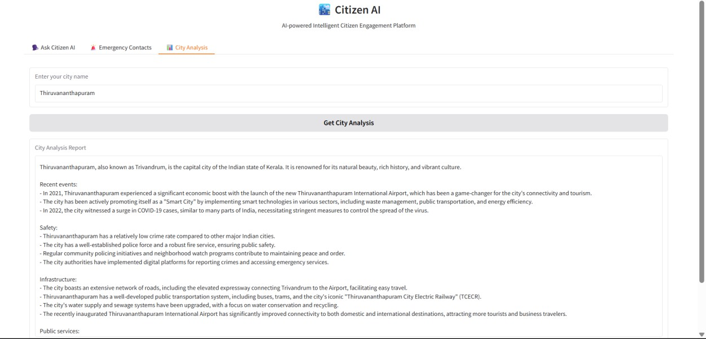

## ADVANTAGES & DISADVANTAGES:

**Advantages:**

1. Enhanced Citizen Engagement: Personalized interactions and streamlined feedback mechanisms encourage active participation.
2. Improved Transparency: Clear and accessible information empowers citizens and fosters trust.
3. Data-Driven Decision Making: AI-driven insights inform policy decisions, ensuring more effective governance.
4. Increased Efficiency: Automated processes and AI-powered tools reduce administrative burdens.

**Disadvantages:**

1. Digital Divide: Limited access to technology may exclude certain citizen groups.
2. Data Privacy Concerns: Collection and analysis of citizen data raise privacy and security concerns.
3. Bias in AI Decision Making: AI algorithms may perpetuate existing biases if not properly designed and trained.
4. Dependence on Technology: Over-reliance on AI may lead to decreased human interaction and empathy.
5. Technical Issues: Platform malfunctions or technical glitches may undermine citizen trust and engagement.

## CONCLUSION:

The platform enhances citizen participation, transparency, and inclusivity in governance through AI-driven technologies. While offering benefits like improved engagement and efficiency, it requires careful consideration of challenges like data privacy and inclusivity. A promising solution for modernizing governance.

## FUTURE SCOPE:

The platform's future scope includes:

1. Expansion to More Cities/Regions
2. Integration with Emerging Technologies (AR, VR, Blockchain)
3. Enhanced AI Capabilities for Personalized Services
4. Increased Focus on Data Analytics and Insights
5. Collaboration with Other Smart City Initiatives

GIT-HUB LINK: <https://github.com/HarshaVardhanButra/Citizen-Ai-Intelligent-Citizen-Engagement-Platform.git>

DEMO VIDEO: https://youtu.be/k_yJSx7soDg?si=Qx9DfyDyrwvnrWVQ